The American University in Cairo
Mechanical Engineering Department
MENG 356: Mechanical Design I

Problem Sheet 4
Shaft Design

The shaft in the figure below rotates at 200 rpm. Pulley A receives 7 kw from below. Gear C delivers 4 kw to the mating gear below it. Chain sprocket D delivers 3 kw to a shaft above.
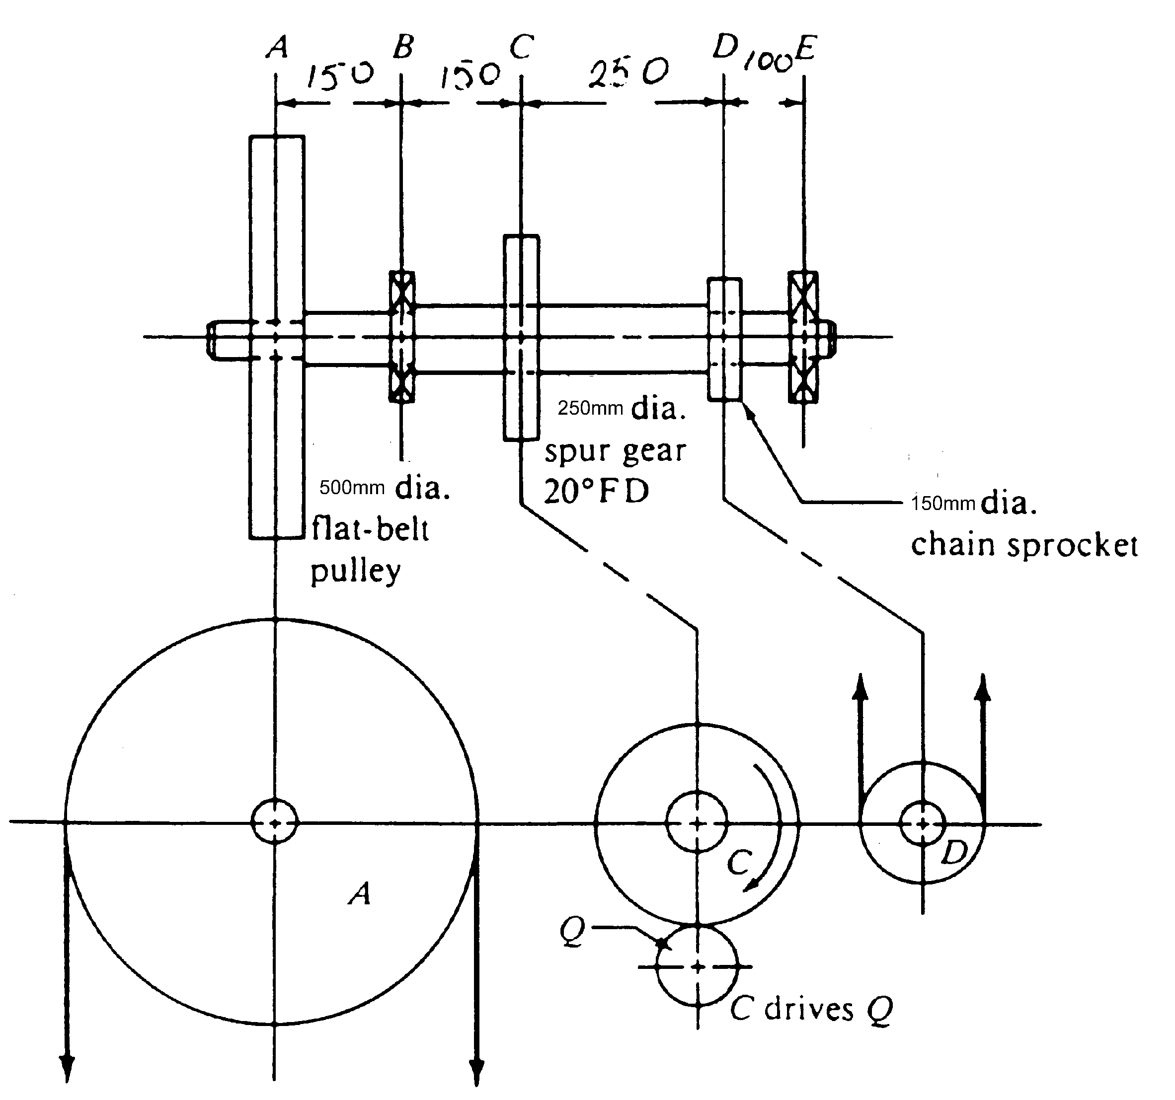

The static torque for a transmitted power P at rotating speed n is
T_{o}(Nm) = 7026P (hp)/n (rpm)
T_{o}(Nm) = 9549P (kW)/n (rpm)
If the transmitted power is P (watts) and the angular velocity is ω (rad/sec), then
T₀ = P/ω (Nm)
